Manuscript template for abstract submission (Times New Roman, Font 14)
Raghu V. Prakash¹, N.S. Joshi² and P.V. Varde² (Times New Roman, Font 11.5)

¹ Indian Institute of Technology Madras, India (Times New Roman, Font 8, Italic)
²Bhabha Atomic Research Center, Mumbai, India (Times New Roman, Font 8, Italic)
raghuprakash@iitm.ac.in, nsjoshi@barc.gov.in, varde@barc.gov.in (Times New Roman, Font 8)

------------------------------------------------------------------------------------------------------------------------------------------------------------------------------------------------------------------------------------------------------------------
Abstract (Times New Roman, Font 9.5, Bold)

Abstract must be written in Times New Roman, font 9. This study has focused on the influence of rotating shaft on the dynamics of rotor-ball bearings system. A mathematical modelling of the system has been carried out by considering shaft as rotating Timoshenko beam model. The radial force of rotor unbalance varied with rotating speed. The contact between balls and races is considered as nonlinear spring, whose stiffness is obtained by using Hertzian contact deformation theory. After the modelling for shaft, the governing equation of bearing has been derived. The proposed mathematical model is validated experimentally.

Keywords: At least four keywords; In alphabetical order; Separated by semicolon; Design of experiments (Times New Roman, font 8, upper case at the beginning of each keyword)
-------------------------------------------------------------------------------------------------------------------------------------------------------------------------------------------------------------------------------------------------------------------------------

1. Introduction (Times New Roman, Font 10, Bold)
This document is a template for Microsoft Word. The author(s) is requested to prepare the final one-column camera-ready version. The author(s) must follow these instructions strictly in order.
The paper is divided into two parts. The first part includes the title, author’s name, abstract, and keywords. The second part is the main body of the paper that includes the references and nomenclature.
The main text must be written in Times New Roman, font 9.5, and line spacing of 12 points. The font size, line spacing, and margin of the template must not be altered.
References should be listed at the end of the paper and arranged in order. References should be cited in the main text by numerals in a square bracket [1-3].

2. Section (Times New Roman, Font 10, Bold)
2.1 Subsection (Times New Roman, 9.5, Italic, Bold)
The second part consisting of the paper body must be edited in single column format. Figures and tables should be located at top or bottom of either column.
Clear original figures in black and white or color should be used. Equations should be numbered consecutively throughout the paper and located at the right margin as in Eq. (1) below. Figures and tables should be placed at the top or at the bottom of each column as in Fig. 1 and Table 1.

Table 1. Material properties
Young’s modulus (GPa) | 210
Poisson’s ratio | 0.3
Yield Strength (MPa) | 433
UTS (MPa) | 460

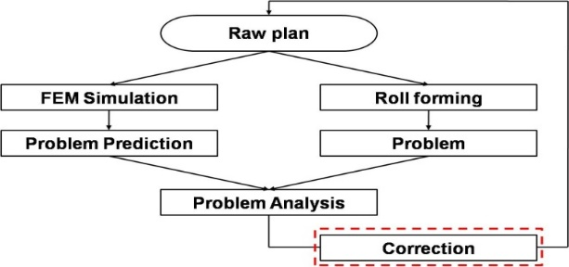

Fig. 1. Flow chart of the process design

For instance, Eq. (1) is used to calculate a response surface as follows:

(1)
(2)

where x_{i} denotes the design variables, n_{d} is the number of design variables, β_{i} is the unknown coefficient, and denotes the design matrix comprising experimental points. The settings of the font size to prepare the equations are:
Main equation: 9.5 pt (Times New Roman),
Subscript/superscript: 6 pt (Times New Roman),
Sub-subscript: 5 pt (Times New Roman),
Symbol: 18 point,
Sub-symbol: 12 point.

2.2 Reference
References (in font 9) should appear in a separate bibliography at the end of the paper, with items referred to by numerals in square brackets. All journal articles must include volume, number, and pages. The journal title, conference title, and book title must be in italic.

3. Conclusions
Conclusion must be very precise. Maximum page limit is 6 pages.

Acknowledgment
This work is supported by Research Program supported by the Department of Science and Technology (program name), Country Name.

References
- C. S. Kim, K. S. Hong, and M. K. Kim, Nonlinear robust control of a hydraulic elevator, Control Engineering Practice, 13 (6) (2005) 789-803.
- R. S. Chandel and S. R. Bala, Effect of welding parameters and groove angle on the soundness of root beads deposited by the SAW process, Proc. of Trends in Welding Research, Gatlinburg, Tennessee, USA (1986) 479-385.
- S. Kalpakjian and S. R. Schmid, Manufacturing Processes for Engineering Materials, Second Ed. Addison-Wesley Publishing Company, New York, USA, (1992).

* Corresponding Author

